Set 3
- Q1. Implement a Python class for a stack data structure (`push`, `pop`, `peek`). Use GitHub Copilot to generate code, test its handling of edge cases, and explain any improvements made.
Prompt :
Give me a code to Implement a Python class for a stack data structure (push, pop, peek). Use GitHub Copilot to generate code, test its handling of edge cases, and explain any improvements made .
Take user inputs
Code:
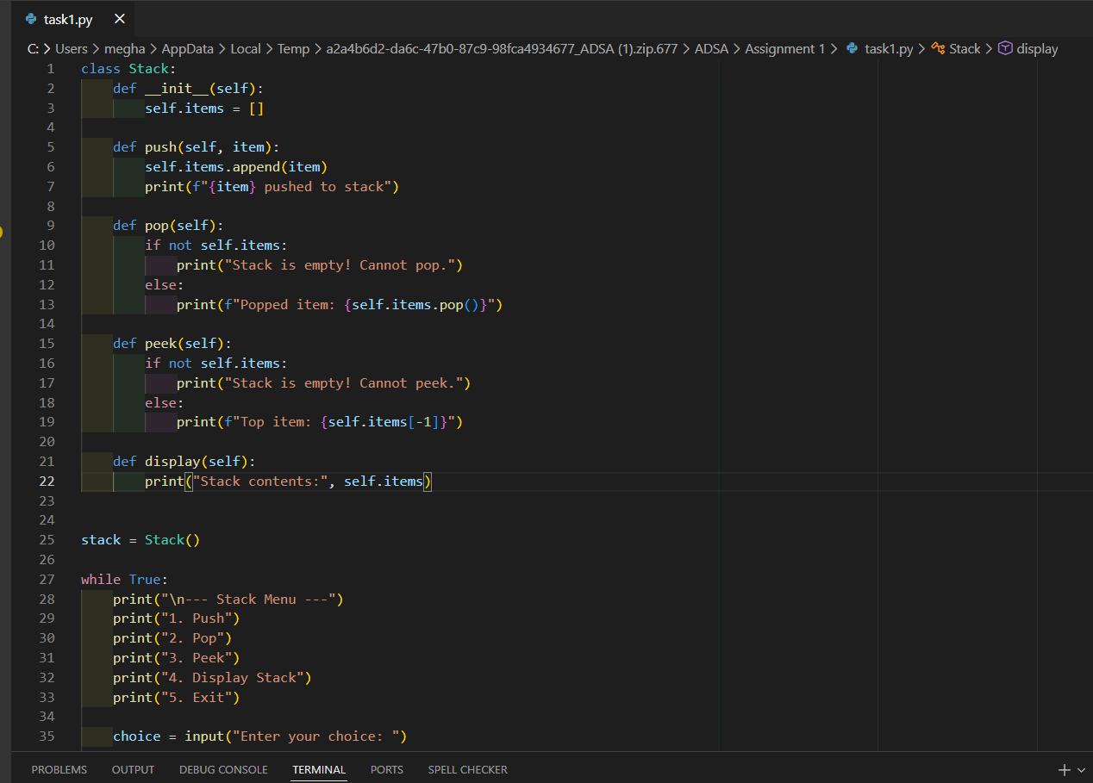
Output:
